|  |  |
| --- | --- |
|  | **Qatar University**  **College of Engineering**  **Department of Computer Science and Engineering** |

Operating Systems-(CMPS 405)

**Task: Project Phase 1**

*Fall 2024*

**Project Group Members:**

Marwan Hashish ID:201701546

Abdulla Jamali ID: 202104080

Nasser Aljufairi ID: 202005009

Murshed Al-Muhannadi ID: 201706102

**Instructor**: ***Eng.Heba Dawoud***

|  |  |  |
| --- | --- | --- |
| **student name** | **Student part in the Project** | **participation percentage** |
| Marwan Hashish | 1. Server-side tasks (VM1):   Configuration tasks SSH and SFTP  Shell scripts: network.sh, traceroute.sh  (70% of the server-side tasks) | 30% |
| Abdulla Jamali | 1. Login.sh 2. Check.sh (client1) | 25% |
| Nasser Aljufairi | Shell scripts :system.sh |  |
| Murshed Al-Muhannadi |  |  |

**Task 1: Setup Server side (VM1)**

**-Create users on the server (client 1, client2)**

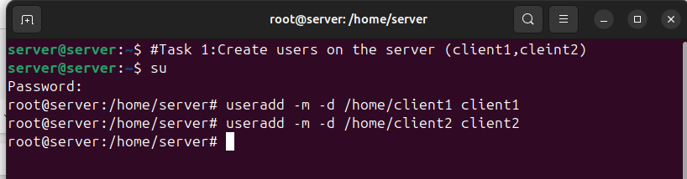-Setting passwords for client1 & client2

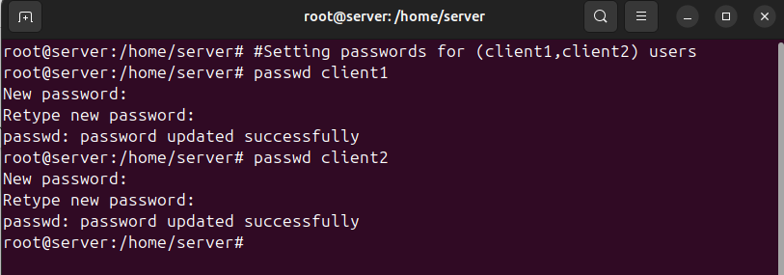-Checking that users are created (client1, client2):



**-Install and enable SHHD**

-Checking if SSH is installed  
-The command to install SSH if it’s not installed: $ sudo apt install openssh-server

But it was already installed so no need for this step.

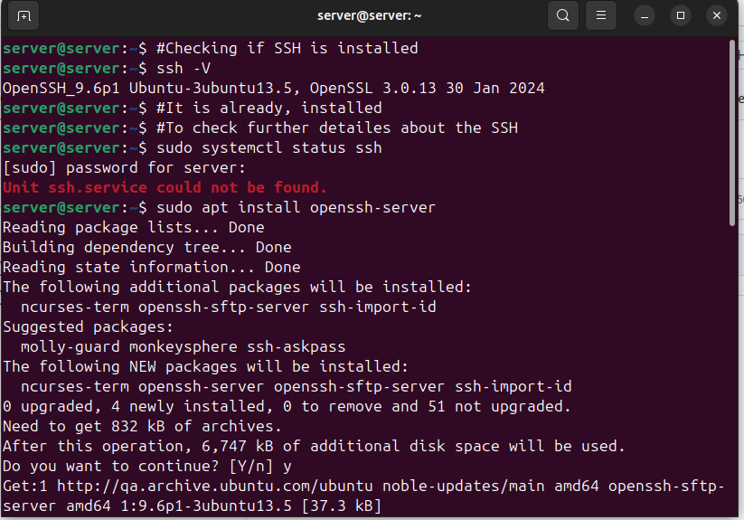-Check if SFTP is working

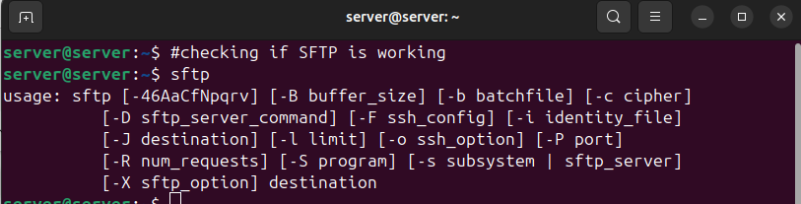

**Task 2 : Configuration**

To Get the IP of the server we did:

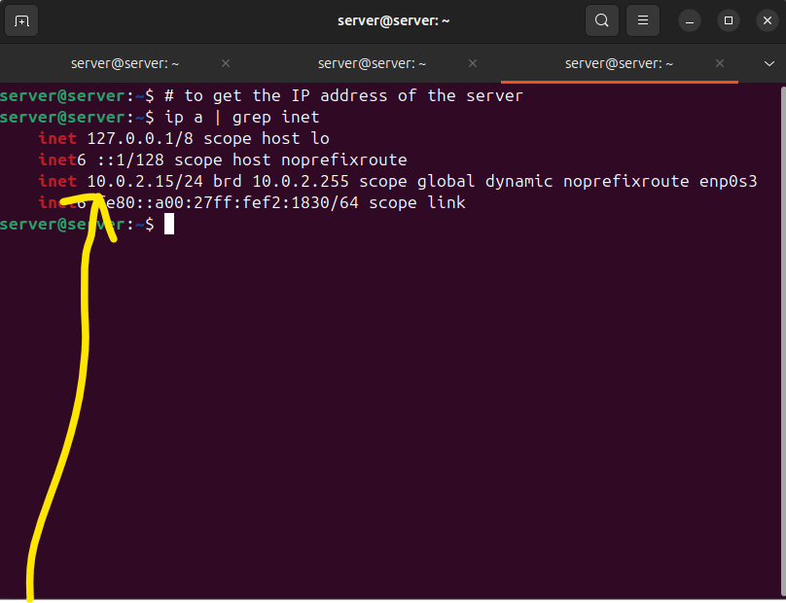

Accessing the server from client 1 using SSH and the ip address of the server we just retrieved:

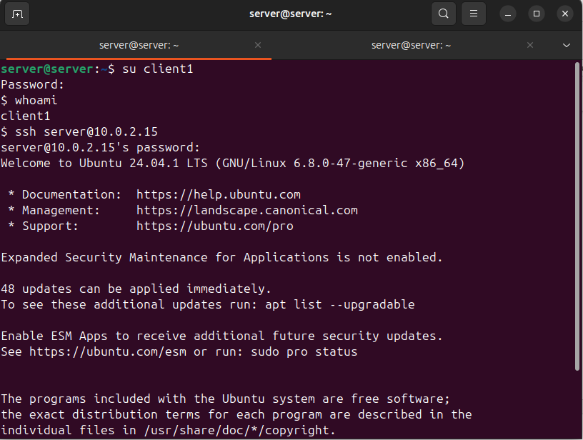

We managed to access the server using SSH (remotely) by client1 user:

-We deduce that SSH is enabled successfully for client 1, we now will do the same for client2:

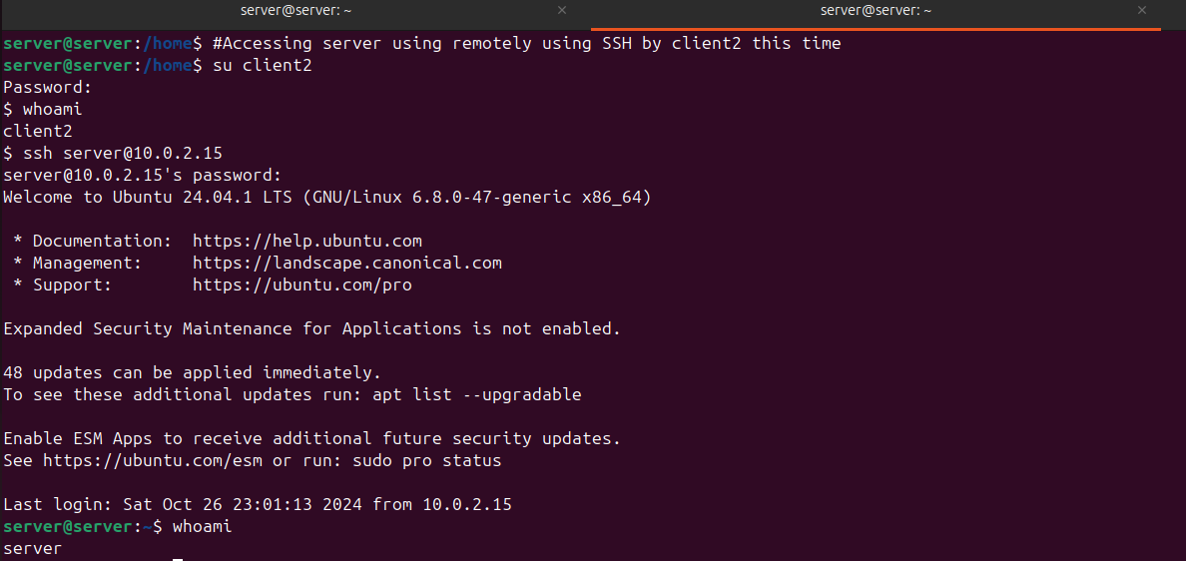

-We deduce that SSH is enabled successfully for client 2

-Mostly the configuration of SSH is done however:

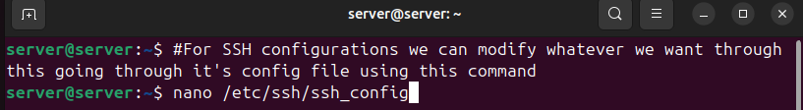

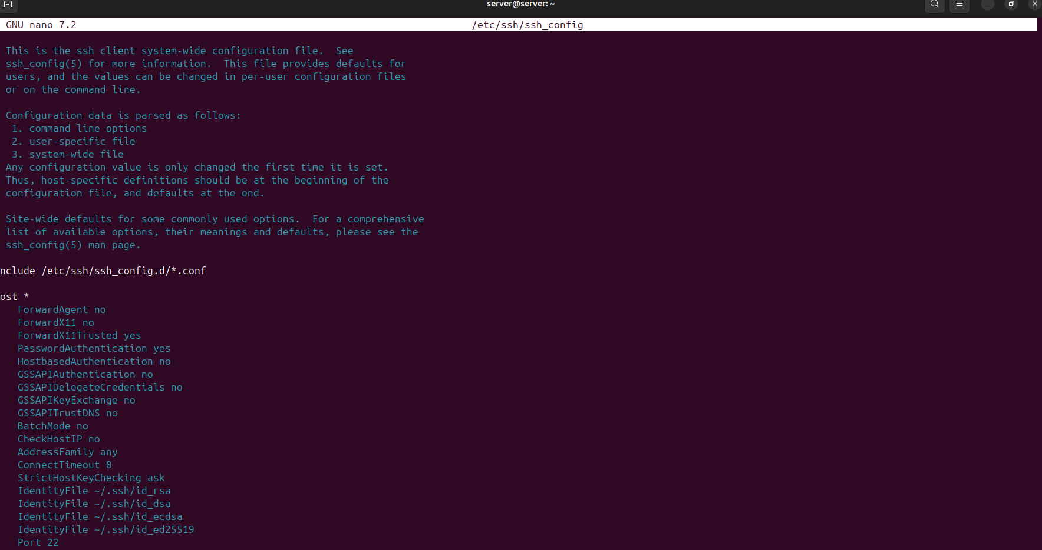

-We can enable or disable based on our needs using: sudo nano /etc/ssh/ssh_config.

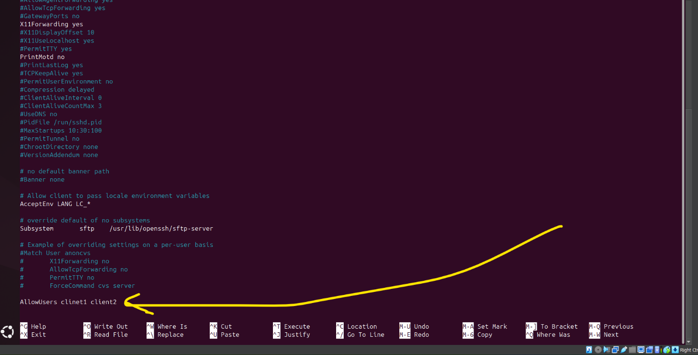

-We add this option for it to only allow the users: client1, client2

-Checking the SCP is working

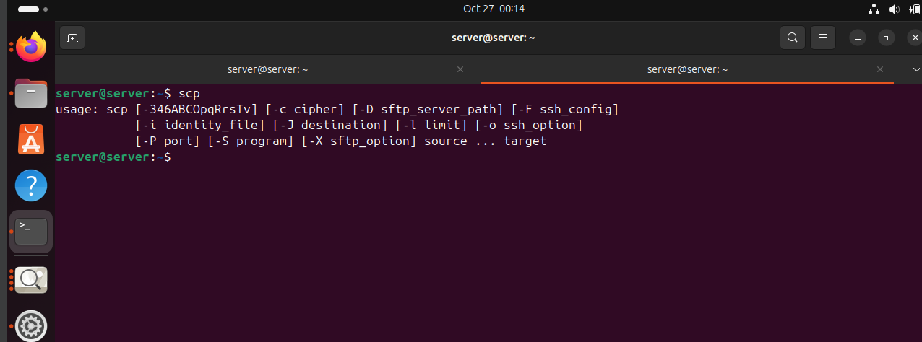

**Task 3: Shell Scripting**

**Network.sh script:**

# Verify and install missing network tools

if ! command -v ping &> /dev/null || ! command -v traceroute &> /dev/null; then

echo "Required network tools not found, installing..."

sudo apt-get update && sudo apt-get install -y iputils-ping traceroute

echo "Network tools successfully installed."

fi

# Function to execute traceroute if ping fails

execute_traceroute() {

local target=$1

echo "Initiating traceroute to $target..."

./traceroute.sh "$target"

}

# Initialize counters for summary

checks_total=0

successful_checks=0

failed_checks=0

# Define retry limits

retry_limit=3

# Iterate over each target IP passed as arguments

for target in "$@"; do

echo "Checking connectivity for $target (Maximum attempts: $retry_limit)"

checks_total=$((checks_total + 1))

attempt_count=1

connection_success=false

# Retry pinging up to retry_limit times

while (( attempt_count <= retry_limit )); do

echo "Attempt $attempt_count: Pinging $target..."

# Ping with 5-second timeout

if ping -c 1 -W 5 "$target" &> /dev/null; then

echo "$(date '+%Y-%m-%d %H:%M:%S') - Successful connection to $target." | tee -a network.log

successful_checks=$((successful_checks + 1))

connection_success=true

break # Stop retries on success

else

echo "Attempt $attempt_count failed to reach $target."

fi

attempt_count=$((attempt_count + 1))

done

# Execute traceroute if all attempts fail

if [ "$connection_success" = false ]; then

echo "All attempts failed for $target. Executing traceroute..."

execute_traceroute "$target"

failed_checks=$((failed_checks + 1))

fi

done

# Generate final summary report

echo "📊 Connectivity Test Summary 📊"

echo "Total Targets Tested: $checks_total"

echo "Successful Connections: $successful_checks"

echo "Failed Connections: $failed_chec

**Traceroute.sh script**

#!/bin/bash

# Function to log messages to both console and log file

log_message() {

echo "$1" | tee -a network.log

}

target_ip=$1

log_message "Starting traceroute to $target_ip..."

{

echo "Displaying Routing Table:"

route -n

echo "System Hostname: $(hostname)"

echo "Performing DNS Resolution Test:"

nslookup google.com

echo "Tracing Route to Google (google.com):"

traceroute google.com

echo "Pinging Google to verify connectivity:"

ping -c 3 google.com

} | tee -a network.log

log_message "Traceroute for $target_ip completed. (Reboot disabled during testing phase)"

# Uncomment the following line to allow reboot after testing completion

# sudo reboot

**Testing Network.sh and traceroute scripts:**

We will conduct two tests. First, we’ll ping the server itself to observe the output of the Network.sh script in the case of a successful connection. The second test will use an invalid IP address to examine the output of the traceroute.sh script.:

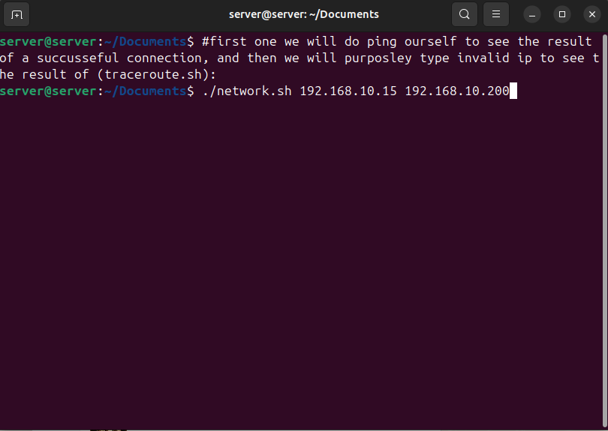

**Result of running (Network.sh) & (traceroute.sh):**

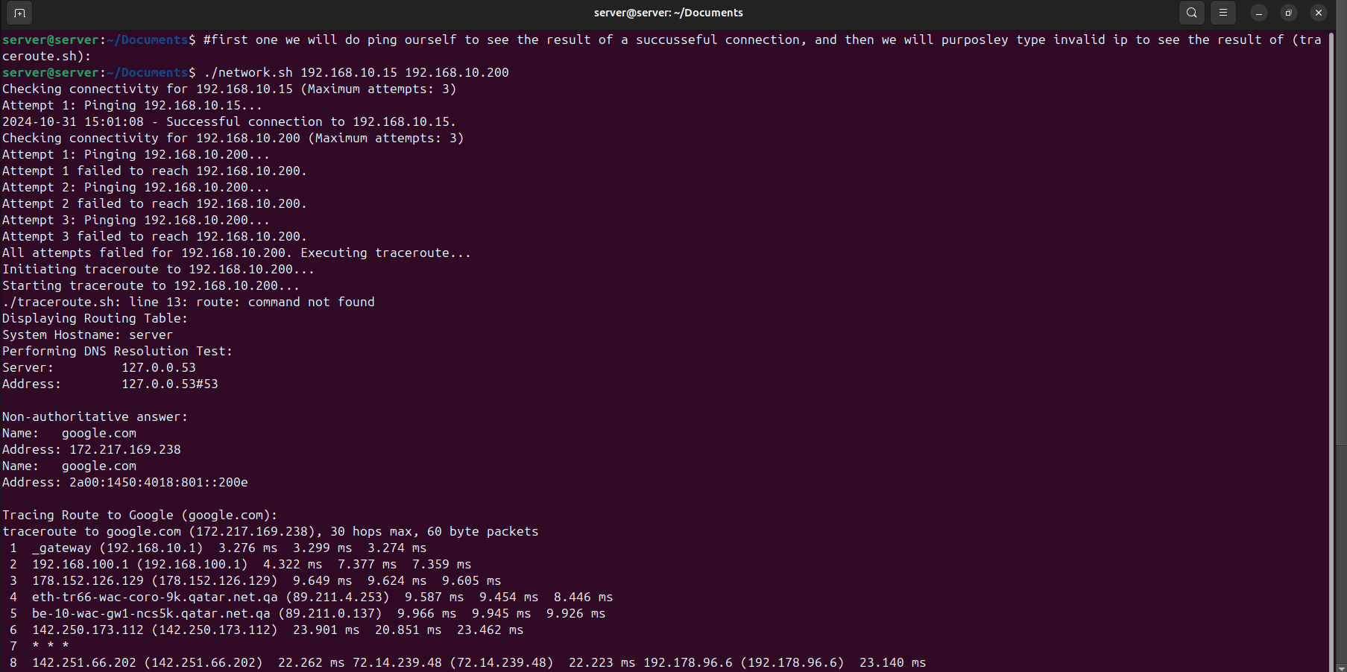

**Checking that that script logs all activities related to network connectivity:**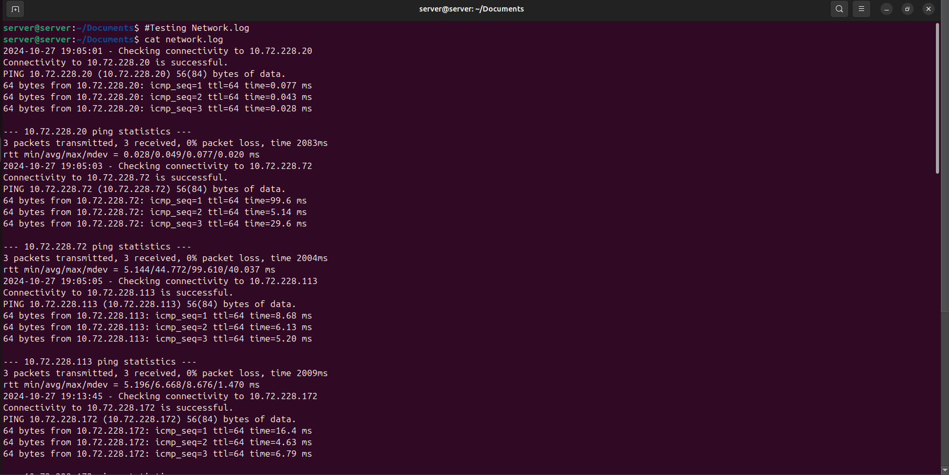

**System.sh script**

#!/bin/bash

# System.sh - Script to display disk and memory usage details for the HOME directory

# This script will generate logs for disk usage, memory, CPU details, and save them to log files.

# Written for Operating Systems Lab (CMPS 405)

# Function to log disk usage information

log_disk_usage() {

echo "Checking disk usage in the HOME directory..."

local log_file="disk_info.log"

{

echo "========== Disk Usage Report =========="

echo "Report Date: $(date)"

echo "----------------------------------------"

echo "Total Disk Space in HOME Directory:"

du -sh ~ 2>/dev/null

echo "\nDisk Usage for Directories and Subdirectories in HOME Directory:"

du -h ~ --max-depth=2 2>/dev/null

echo "----------------------------------------"

} | tee "$log_file"

echo "Disk usage data logged to $log_file"

}

# Function to log memory and CPU details

log_memory_cpu_info() {

echo "Gathering memory and CPU data..."

local log_file="mem_cpu_info.log"

{

echo "========== Memory and CPU Info =========="

echo "Report Date: $(date)"

echo "-----------------------------------------"

# Memory usage information (free and used memory percentage)

echo "Memory Usage Summary:"

free_output=$(free -m)

total_memory=$(echo "$free_output" | awk '/^Mem:/ {print $2}')

used_memory=$(echo "$free_output" | awk '/^Mem:/ {print $3}')

free_memory=$(echo "$free_output" | awk '/^Mem:/ {print $4}')

used_percentage=$(( (used_memory * 100) / total_memory ))

free_percentage=$(( (free_memory * 100) / total_memory ))

echo "Memory Used: $used_percentage%"

echo "Memory Free: $free_percentage%"

echo "-----------------------------------------"

# CPU information

echo "CPU Information:"

cpu_model=$(lscpu | grep "Model name" | awk -F ':' '{print $2}' | sed 's/^ *//g')

cpu_cores=$(lscpu | grep "^CPU(s):" | awk -F ':' '{print $2}' | sed 's/^ *//g')

echo "CPU Model: $cpu_model"

echo "CPU Cores: $cpu_cores"

echo "-----------------------------------------"

} | tee "$log_file"

echo "Memory and CPU data logged to $log_file"

}

# Main execution starts here

# Log disk usage and memory/CPU info

log_disk_usage

log_memory_cpu_info

# Final message

echo "System information has been gathered and saved."

**Testing system.sh script:**

